product of primary metabolitas

The Photosynthesis
The Photosynthetic products are energy rich organic compounds. The potential chemical energy of these compounds comes from the light energy.
The light energy to be effective in photosynthesis must be absorbed by a suitable pigment. This vital role is performed by the green pigment, chlorophylls, in plants.

Chlorophyll
There are at least seven types of chlorophylls known: chlorophylls a, b, c, d and e, bacteriochlorophyll and bacterioviridin. All these chlorophyll molecules contain a tetrapyrrole skeleton formed into a ring with an atom of magnesium in the centre of the ring. A so-called pyrrole molecule contains a skeleton of five atoms, four of carbon and one nitrogen and the five are arranged in a ring. Four such pyrroles arranged in a ring form the head of a chlorophyll molecule. Attached to this porphyrin ring at one point is an alcohol (phytol) ―tail‖, a long chain of linked carbons. Relatively minor variations in the kinds and groupings of other atoms joined to this head and tail skeleton account for the differences among different kinds of chlorophylls.
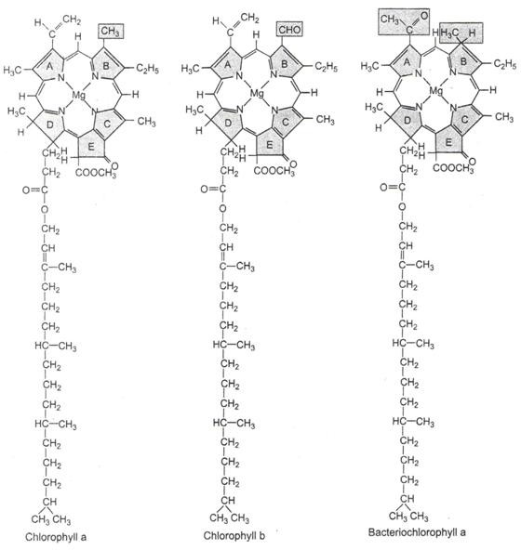
Fig.5.1 Structures of Chlorophyll a, chlorophyll b and bacteriochlorophyll

Chlorophylls ‗a‘ and ‗b‘ are the two most abundant chlorophylls. Chlorophyll a is found in all the autotrophic plants except the photosynthetic bacteria. Chlorophyll b is absent in the blue

green, brown and red algae. The other chlorophylls c, d, e are found only in algae and in combination with chlorophyll a. Chlorophyll a possess –CH3 , a methyl group which is replaced by –CHO, an aldehyde group in chlorophyll b. The structures of chlorophyll a, chlorophyll b and bacteriochlorophyll are given in Fig.5.1.
The molecular formulae of the chlorophylls are given below:
Chlorophyll a : C₅₅H ₇₂O₅N₄Mg Chlorophyll b : C₅₅H₇₀O₆N₄Mg
Both the chlorophylls a and b have hydrophilic Mg – Porphyrin head and a lipophilic phytol tail.

The chlorophylls are primarily located within the grana thylakoids. The chlorophyll molecules form a monolayer between the protein and lipid layers of the membranes of the thylakoids. The hydrophilic heads of the chlorophyll molecules are embedded within the protein layer while the lipophilic tails are located within the lipid layer.

The Absorption Spectrum
The portion of the electromagnetic spectrum which participates in photosynthesis is from 300 to 900 nm. In green plants only the visible spectrum (400-750 nm) is effective in photosynthesis. Photosynthetic green bacteria can absorb wavelengths from 375-800 nm while purple photosynthetic bacteria absorb 300 to 950 nm.
The chlorophyll pigments chiefly absorb in the violet blue and red parts of the spectrum. The absorption band in the violet blue region is called Soret band.
The chlorophyll a has two prominent absorption peaks at 430 nm and 662 nm. There are reports of different forms of chlorophyll a with absorption peaks at 660, 670, 680, 685, 690 and 695 to 720 nanometers. These variations are perhaps due to the environmental changes. The absorption peaks for chlorophyll b occur at 453 and 642 nm as shown in Fig.5.2.
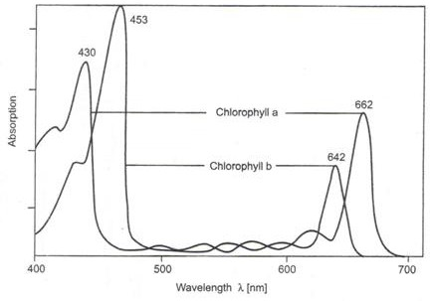
Fig.5.2 Absorption spectrum of chlorophyll a and chlorophyll b
The solubility properties of the two pigments differ. Chlorophyll a dissolves very well in petroleum ether while chlorophyll b in methyl alcohol.

The distribution of pigments and their absorption peaks are given in Table-1
S.No. | Type of Pigments | Distribution in Plant Kingdom | Absorption peaks in cells in nm
1 | Chl a | All green Plants | 435 670-680
2 | Chl b | All green plants except diatoms brown, red and blue green algae | 480 650
3 | Chl c | Diatoms and brown algae | - 645
4 | Chl d | Some red algae | - 740
5 | Protochlorophyll | Etiolated Plants | - -
6 | Bacterioviridin | Green Sulphur Bacteria | - 750 or 760
7 | Bacteriochlorophyll | Purple sulphur bacteria | - 800, 850 and 890

Carotenoids
The carotenoids are the main accessory pigments in photosynthesis. They transfer the light energy to chlorophyll for photosynthesis. The carotenoids are widely distributed in plants. They occur in bacteria, algae and higher plants. They include orange carotenes and yellow xanthophylls. They absorb wavelength 400 nm to 500 nm because of which they are orange in colour. Of the carotenes β-carotene is the abundant type. It absorbs blue light, and, therefore, appears yellow in colour. ά-carotene is present in very small amounts in certain species. The carotenoids perform two types of functions in the green plants. They trap light energy and transfer it to the chlorophyll a particularly in algae and to some extent in higher plants. In higher plants this function is performed by lutein of the xanthophylls and β-carotene.
At high light intensities the entire cell apparatus is oxidized by atmospheric oxygen into carbon dioxide. This process is termed photo oxidation which is as good as combustion. The carotenoids (β-carotene) protect the photosynthetic apparatus from this type of destruction by trapping and dissipating the excess excitation energy which would have otherwise converted molecular oxygen to a highly reactive and mutagenic superoxide O₂. The dissipation of excess energy in the form of heat is facilitated by xanthophylls cycle.
Carotenoids consist of long chains of carbon atoms linked by conjugated single and double bonds with six carbon rings as each end Fig.5.3.

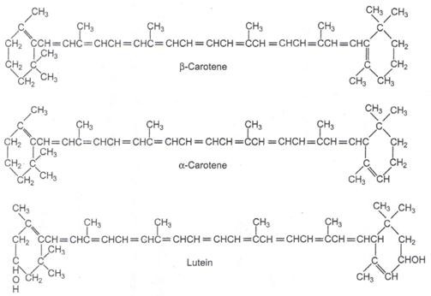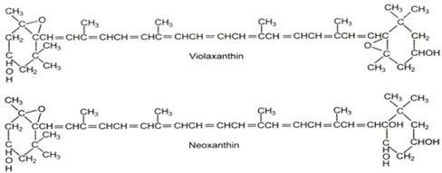

Fig.5.3 The molecular structures of the major carotenoids of higher plants

The carotenes are hydrocarbons i.e. they contain carbon and hydrogen. The xanthophylls (also known as carotenols) are alcohols and ketones and contain oxygen, carbon and hydrogen. Like chlorophylls they are located in chloroplasts and also in chromoplasts. Carotenes are named after carrot in which they are abundant. The distribution of the carotenoids in the plant kingdom is shown in the Table 2.

Table 2: The Carotenoids
Carotenes
Types Carotenoids | of | Distribution in Plant Kingdom |  |  |  | Characteristic absorption peaks (nm)
ά – Carotene |  | Many leaves and certain algae. In red algae and a group of green algae called siphonales. |  |  |  | In hexane, at 420, 440, 470
Β-Carotene |  | Main carotene of all other plants. |  |  |  | In hexane, at 425, 450, 480
γ – Carotene |  | Major carotene of green sulphur bacteria; traces in some plants. |  |  |  | In hexane, at 440. 460, 495
Carotenols ( Also called Xanthophylls)
Luteol |  | Major carotenol of green leaves, green algae and red algae |  |  |  | In ethanol at 425, 445, 475
Violaxanthol |  | Second major carotenol of leaves |  |  |  | In ethanol, at 425, 450, 475
Fucoxanthol |  | Major carotenol brown algae | of | diatoms | and | In hexane, at 425, 450, 475
Spirilloxanthol |  | Common in purple bacteria |  |  |  | In hexane, at 464, 490, 524

Phycobilins
Englemann found blue green light to be very effective in increasing the rate of photosynthesis of brown and red algae. In fact the red algae gave the best result in green light. Since chlorophylls hardly absorb green light it became obvious that some other accessory pigment was involved. Several workers have since then demonstrated the role of phycobilins and carotenoids in photosynthesis. The irradiation of carotenoids causes fluorescence of chlorophyll suggesting the transfer of energy by accessory pigments to chlorophyll a during photosynthesis.
In blue-green and red algae some additional pigments known as phycobilins are present. They are also tetrapyrroles like chlorophylls but the four joined pyrrole rings form a straight chain. Like anthocyanins they also mask the green color of the chlorophylls. They are, however, intimately associated with the cholorophylls. The light absorbed by them can be used in photosynthesis. Phycobilins include red coloured phycoerythrins and blue coloured phycocyanins found in red and blue-green algae respectively. Phycoerythrin absorbs the green light the best. Phycocyanin absorbs blue light the best.

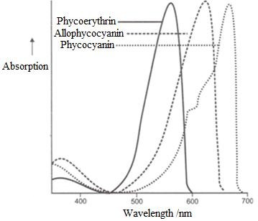
Fig.5.4 Absorption spectrum of three phycobilins

The distribution of phycobilins in the plant kingdom is shown in the given table. (Table-3)

Table-3
Type of  Phycobilins | Distribution in plant  kingdom | Absorption peaks in cells in nm
Phycocyanins | Mostly in blue green algae | In water and in vivo, at 618
Phycoerythrins | Mostly in red algae | In water and in vivo, at 490, 546 and  576
Allophycocyanins | Blue green and red algae | In phosphate buffer at PH 6.5 at 654

Anthocyanins
The colour of leaves is modified in certain plants due to the presence of purple pigment called anthocyanins. They are formed by several rings of atoms, the rings being joined in complex ways. Anthocyanins are soluble in water; hence they occur in the vacuolar sap of the cells. This pigment does not take any part in photosynthesis. Anthocyanin is not present in the cytoplasm.

CONCEPT OF TWO PHOTOSYSTEMS

There are two reactions involved in photosynthesis. The first reaction requires light and is called the light or Hill reaction. The second reaction does not require light and is called the dark or Blackman reaction.
- The light reaction is a photochemical reaction, while the dark reaction is a thermochemical reaction. The unit of photosynthesis is believed to consist of two types of centres,

photosystem I and photosystem II. These are excited at different wavelengths of light. The two systems are linked by redox catalysts. The light reaction involves two processes, photophosphorylation and photolysis of water. In photophosphorylation there is conversion of light energy into chemical energy. Photophosphorylation is of two types, cyclic photophosphorylation and noncyclic photophosphorylation.
- The dark reaction takes place through a series of steps known as the Calvin-Benson cycle. The details of different stages of photosynthesis will now be taken up.

In higher plants and algae two pigment systems are involved in photophosphorylation. These are called photosystems I and II. The pigments of the two systems are known as pigment system I (PS I) and pigment system II (PS II), respectively. PS I and PS II are structurally distinct. PS I and PS II both contain chlorophyll a, chlorophyll b and carotenoids. The distribution of the two pigments however, varies in the two systems. PS I contain more carotenes than PS II. Xanthophyll predominates in PS II. The primary photosynthetic pigment of both systems is chlorophyll a. In blue-green and red algae phycobiliproteins (formerly phycoerythrin and phycocyanin) are present as accessory pigments.

.

PHOTOPHOSPHORYLATION

There are two types of phtophosphorylations in the chloroplasts of plants:
- Non cyclic photophosphorylation
- Cyclic photophosphorylation.

Non-Cyclic Photophosphorylation
The famous Z scheme of non-cyclic phtophosphorylation was developed as a result of work of several research workers. According to Hill and Bendall (1960), Rabinowithch and Govindjee (1965) and others the photochemical reactions occur in series, the product of one being used up by the other. It has undergone modifications from time due to discovery of new electron carriers.

When the chlorophyll is photoexcited the electron gets dislodged from the chlorophyll molecule leaving a ‗hole‘ in it. The ‗hole‘ left by displaced electron is soon filled up by the return of the same electron or another one (cyclic and non-cyclic electron transport). In pigment system I there are 200 chlorophyll a molecules and just one P700 molecule. Any one or all of the chlorophyll a molecules can absorb red or blue photons of light and can pass on the excitation energy to P700 molecule which alone can lose the electron. Due to very tight arrangement of the chlorophyll a 683 molecules within PS I the singlet excitation energy resulting from the absorption of a light quantum by Chl a 683 migrates from one molecule to another by resonance transfer until it reaches a chlorophyll a 683 molecule which is adjacent to the long wave absorbing pigment (P700). The energy is then passed as an excitation to the P700 molecule which is the reaction centre. P700 attains the first excited singlet state and loses an electron to an electron acceptor. The PSI function has been compared to an antenna which causes the
‗funneling‘ of photons into an ‗energy trap‘ or ‗sink‘ (P700) or to a lens which concentrates light into a focal point (P700).
The sequential steps in the electron transport chain are discussed under the following headings:
- PS II AND Photolysis of water: One of the two primary photochemical reactions in photosynthesis is the absorption of red light by PS II. According to Barber et al. (1999) PS II is a multi subunit protein super complex which has two unique chlorophyll a P680 reaction centers (dimer) and some antenna complexes. After receiving light the P680 reaction center gets photoexcited as a result of which an electron is ejected. The excited form of P680 known as P680* loses its electron to pheophytin, which is the primary electron acceptor. Pheophytin is a type of chlorophyll a in which magnesium is substituted by two hydrogens. According to Okamura et al. (2000) the electron is transferred from pheophytin to plastoquinones Q_{A} and then to Q_{B}. The two are bound to the reaction center. The second plastoquinone Q_{B} after receiving two electrons is reduced to Q_{B}-² which reacts with two protons of the stroma to form QH₂ (plastohydroquinone). QH₂ which is a small nonpolar molecule was earlier bound to PS II is freed from it. It moves into the non-polar part of the phospholipids and transfers the electrons to cytochrome b₆f complex. (Fig 5.6)

- The Cytochrome Complex : The cytochrome b₆f complex is also a large multi subunit protein. It has many prosthetic groups. There are two b type hemes. a c type heme (cytochrome f), and a Rieske iron sulphur protein (FeSr) present in the complex.
In the non-cyclic or linear type of electron transfer QH₂ transfers one electron to Rieske FeS protein which is present on the side of the lumen and transfers another electron to one or the cytochrome b. The Rieske FeS protein transfers its electron to cytochrome f, which is also present on the lumelal side of the thylakoid membrane. In the process two H⁺ ions are released into the lumen.
In another mechanism for the transfer of protons and electrons in the cytochrome b₆f complex, called cyclic process, the other QH₂ electron received by cytochrome b is transferred which after

passing through the two b type cytoquinone reduces the semiquinone to plastohydroquinone. In the process two protons are taken up from the stroma so that a total of 4 protons are released in the lumen. ( Fig 5.6).
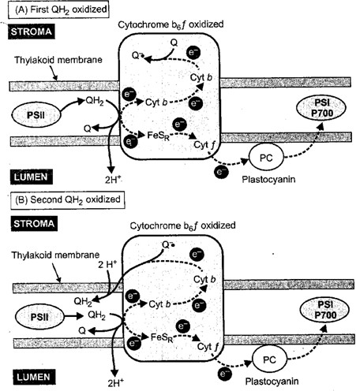

Fig.5.6 Diagram to show the non-cyclic type of electron transport in the cytochrome b₆f complex.
A. Linear or cyclic transport; B. Cyclic transport (Redrawn from Taiz and Zeiger, 2002)

- Plastocyanin, the Electron Donor to PS I: The plastocyanin accepts electrons from cytochrome b₆f complex and donates them to PS I. It is the only copper containing electron carrier in the electron transport chain of photosynthesis. It is a small water soluble protein and is present on the side of the lumen. Plastocyanin does not appear to be indispensable since in some algae non-cylic electron transport chain occurs even in its absence.
- The PS I: According to Jordan et al., the PS I is also a large multi subunit complex. It contains not only the reaction center P700 but also a number of components which participate in the transfer of electrons. They are all present around two big sized proteins called PsA and PsB and some small proteins. The P700 is positioned in such a manner in the membrane that the electron is easily ejected. The primary electron acceptor is A₀ which is a type of chlorophyll. The next electron acceptor is A1 which is a quinone. The electron is then transferred to soluble ferredoxin (Fd) through a series of iron sulphur proteins namely Fe Sx, Fe SA and Fe SB.
The electrons far transferred from ferredoxin to ferredoxin-NADP⁺ reductase (FNR) which donates them to NADP⁺ to produce NADPH (Vishniac and Ochoa, 1951).

- The ATP Synthase: It is a large complex enzyme and is known by several names such as ATPase, the coupling factor, and CF₀-CF_{1*} This enzyme is situated only at the edges of granal thylakoids and in the stroma lamella and therefore, the protons coming from photolysis of H₂O and from cytochrome b₆f complex have to move great distances laterally to reach it. One of the two components of the enzyme called CF₀ is hydrophobic and is bound to the membrane. The other component termed CF₁ projects into the stroma.
According to Peter Mitchell‘s chemiosmotic theory the energy required for the synthesis of ATP is provided by proton motive force. The proton motive force is created by the proton chemical potential and the transmembrane electrical potential. The H⁺ ions released during photolysis of water accumulate in the lumen of the thylaoids.. The accumulated H⁺ ions in the lumen try to leak back into the stroma through the ATP synthase. The protons enter the channel formed by CF₀ and when they cross through the catalytic sites of β-polypeptide of CF₁, the proton motive force breaks, releases energy as a result of which ATP is generated . The latest detailed Z scheme is given in Fig. 5.7.

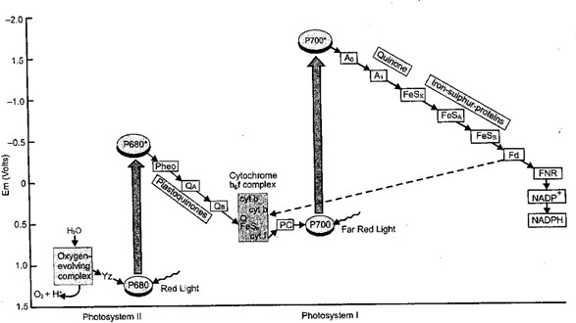
Fig. 5.7 Current concept of the Z-scheme of light phase of photosynthesis. (After Blankenship and Prince, 1985). The cyclic electron transport is indicated by dotted line.

- Cyclic Photophosphorylation
Another type of photophosphorylation can also take place under certain conditions e.g. when the amount of available NADP⁺ is low or PS II is absent or monochromatic light beyond 680 nm is

given to the plant in the laboratory. This process involves only pigment system I and, therefore, photolysis of water and the consequent evolution of oxygen does not take place . Non cyclic electron transfer does not take place and NADPH is not formed. The CO₂ assimilation is retarded (red drop). The photosynthetic enhancement can, however, take place if PS II wavelength of light is also given to bring into action the noncyclic phtophosphorylation.
In cyclic electron transfer the electron flows from photoexcited P700 to X, A and B, FRS and then to ferredoxin, which unable to pass electrons to NADP⁺ transfers them to cytochrome b₆ (E⁰ = - 0.06 V). The electron is ultimately cycled back to P700 via PQ, FeS, cytochrome f and plastocyanin. ATP molecule is formed either between ferredoxin and cytochrome b₆ or between cytochrome b₆ and cytochrome f or at both steps.
It is however, doubtful whether cyclic process occurs in normal photosynthesis (VAN Niel, 1962), According to Ramirex et al. (1968) it may serve as the source of ATP for biosynthetic processes occurring in chloroplasts that are not on the main photosynthetic path of carbohydrate synthesis but branch off from this path for the synthesis of protein, DNA, RNA, starch, lipids, pigments etc. Part of the ATP requirement of the dark phase of photosynthesis is also met with by this process.
The cyclic electron transport chain was studied by Arnon. It is not inhibited by 3(3), 4- dichlorophenyl 1, 1-dimethylurea: DCMU). This inhibitor, however, inhibits non-cyclic transport of electrons. Cytocrome b₆ is an electron carrier which participates exclusively in cyclic electron transport chain.
Table 4: Difference between cyclic and non cyclic photophosphorylation
S.No. | Cyclic Photophosphorylation | Noncyclic Photophosphorylation
1 | Only photosystem I functions in cyclic photophosphorylation. | Both photosystem I and II function in noncyclic photophosphorylation.
2 | Cyclic photophosphorylation functions in a closed loop. Electrons released from chlorophyll to acceptor return to chlorophyll. | An independent electron donor is necessary. Water is the ultimate source of electrons. NADP⁺ is the final electron acceptor.
3 | There is no net production of reduced compounds. NADPH₂ is not formed and assimilation of CO₂ is retarded. | NADPH₂ is the reduced compound formed. It is utilized in carbon assimilation.
4 | Oxygen is not evolved. | ATP formation is coupled to evolution of oxygen.
5 | In bacteria only cyclic | In green plants noncyclic

 | photophosphorylation takes place. | photophosphorylation also occurs.
6 | Cyclic photophosphorylation is not sensitive to either antimycin or dichlorophenyl-dimethly-urea (DCMU). | DCMU inhibits flow of electrons from water to NADP+ and thus stops noncyclic photophosphorylation.
7 | The flow of electrons is as follows  Chl (PS-I)-FRS-Fd-Cyt. b₆-Cyt. f-PC- Chl (PS-I) | The flow of electrons is as follows:  PS-II-Q-PQ-Cyt.f-PC-PS-I-FRS-NADP+

CALVIN CYCLE / DARK REACTION

During the dark reactions of photosynthesis carbon dioxide is reduced to form carbohydrates. The term dark reaction implies that the reaction is not dependent on light. Synthesis of carbohydrates proceeds in the dark. The dark reaction has been worked out mainly by Calvin, Bensn and Bassham. The pathway by which carbon dioxide is fixed into carbohydrates is called the Calvin-Benson cycle or Calvin-Bassham cycle. Carbon dioxide and water are used to generate carbohydrate in the presence of ATP and NADPH. (Fig.5.8).

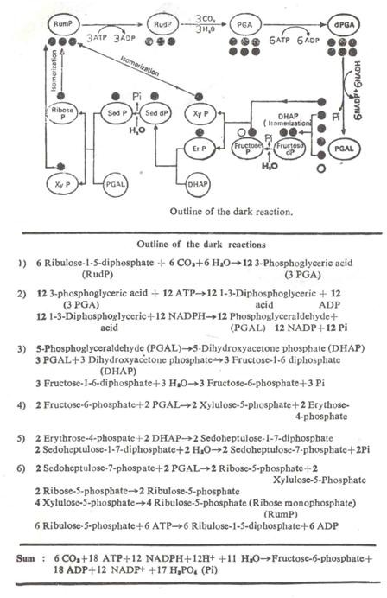
Fig.5.8 Outline of the dark reactions

Production of PGA
Calvin and his co-workers found that the first product to accumulate during photosynthesis was phosphoglyceric acid (PGA). This arises as follows.

Carbon dioxide is first attached to ribulose-1-5-diphosphate (RudP) a 5-carbon atom compound, to from an intermediate 6-carbon compound. Each molecule of this compound then splits to form two molecules of PGA. Radioactive carbon dioxide (¹⁴CO₂) was used in the experiment, and this CO₂ contributed one carbon atom of the two PGA molecules formed only one has radi oactive carbon. Thus only one free molecule of PGA is formed per molecule of CO₂ entering the cycle. Actually, 6 molecules of RudP and 6 molecules of CO₂ react to produce 12 molecules of PGA.
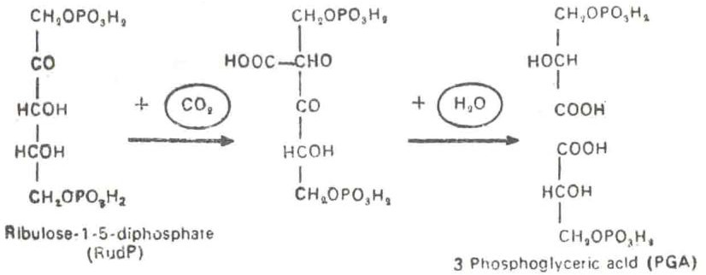

Production of PGAL
Phosphoglyceric acid (PGA) is reduced to phosphoglyceraldehyde (PGAL). This Process is the reverse of the oxidation step in glycolysis when PGA is oxidized to PGAL. In all 12 molecules of PGAL are produced from the 6 molecules of RudP. The reaction takes place in two steps. Firstly, PGA is phosphorylated by ATP to 1, 3-diphosphoglyceric acid.

Secondly, 1, 3- diphosphoglyceric acid is reduced by NADPH + H⁺ to Phosphoglyceraldehyde (PGAL)
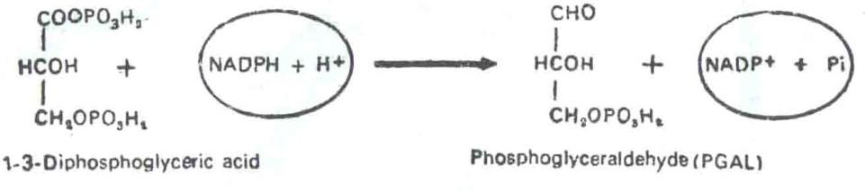

Production of Fructose-6- phosphate
PGAL is converted into its isomer dihydroxyactone phosphate (DHAP), as in glycolysis. DHAP condense with PGAL to from fructose-1-6-diphosphate.

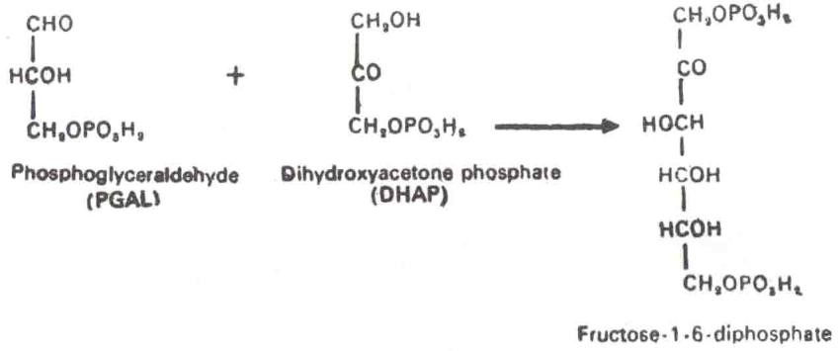

This process is the reverse of the breakdown of fructose-1-6-diphosphate in glycolysis.

One phosphate group is removed from fructose 1-6 diphosphate (dephosphorylation) resulting in the formation of fructose-6-phosphate.
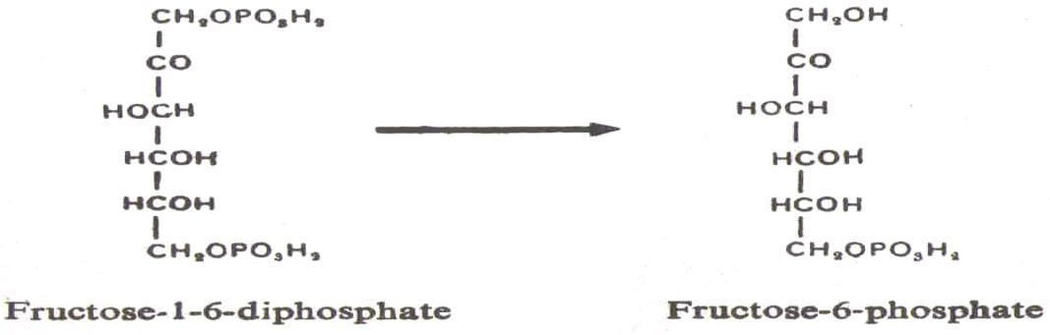

Production of Xylulose Phosphate
Fructose-6-phosphate reacts with PGAL to yield a pentose (5C), xylulose-5-phosphate, and a tetrose (4C), erythrose-4-phosphate the reaction is catalysed by the enzyme transketolase.
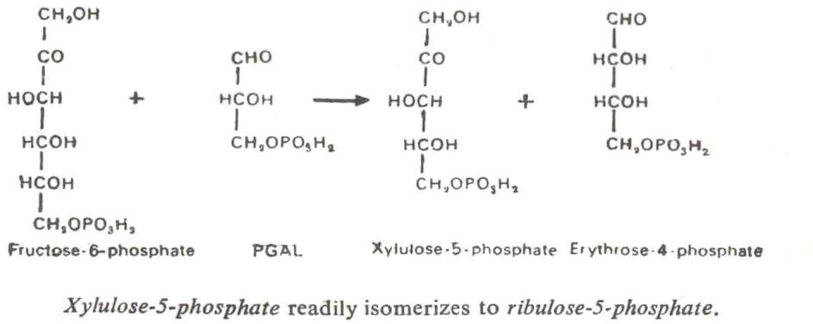

Formation of Sedoheptulose-1, 7-diphosphate
Erythrose-4-phosphate reacts with DHAP to from sedoheptulose-1-7 disposphate, the reaction being catalysed by the enzyme transaldolase.

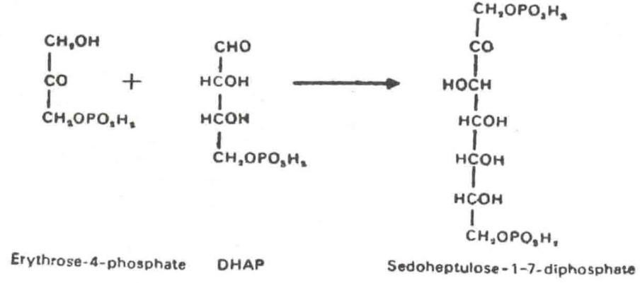

Sedoheptulose 1-7-diphosphate loses one phosphate (dephosphorylation) and becomes sedoheptulose-7-diphosphate.

Formation of Ribose-5-phosphate
Sedoheptulose-7-phosphate reacts with another molecule of PGAL to from ribose-5-phosphate and xyluose-5-phosphate. Both these products readily isomerizes to ribulose-5-phosphate or ribulose monophosphate (RumP)
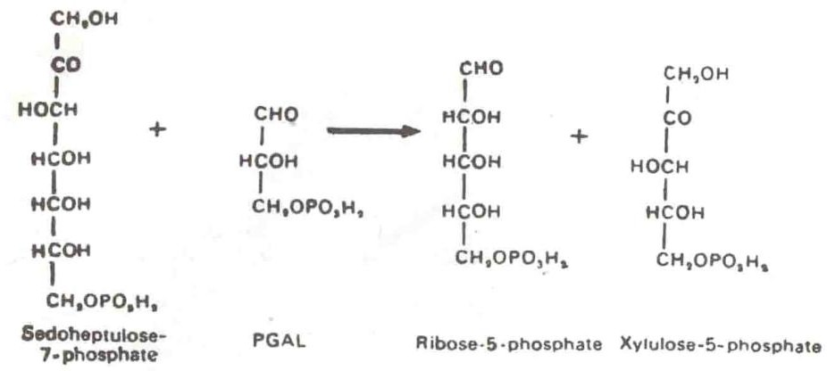

C4 PATHWAYS

Most of the C₄ plants are monocots. There are also about 300 species of C₄ plants in dicots. About 900 species belonging to 19 families are C₄ plants. The primary objective of the Hatch Slack cycle is to trap atmospheric CO₂ in the maximum amount and to transport it into the bundle sheath cells so that the rate of Calvin cycle is enhanced.
Till 1965 the mechanism of the photosynthetic CO₂ fixation was believed to occur only by means of what is popularly known as Calvin cycle. In 1965 H.P. Kortschak, C.E. Hart can G.O. Burr working with C¹⁴O2 on sugar cane leaves found highly efficient photosynthesis and C₄ dicarboxylic acid, malate and aspartate to be the major labeled products (80% of radio activity) in very short periods of photosynthesis. Working on grasses this observation was confirmed by

M.D. Hatch and C.R. Slack of David North Plant Research Centre, Queensland, Australia in 1967. The Hatch Slack pathway, as this alternative CO₂ fixation is called, has been found to occur in tropical and subtropical grasses and some dicotyledons. Some of the important C₄ plants are sugarcane, maize, sorghum etc. It is interesting to note that even within a single genus a sub- tropical species Atriplex rosea exhibits Hatch Slack pathway whereas the temperate species Atriplex hastata has only the Calvin cycle.
There are 4 distinct stages in the C₄ cycle:
- CO₂ fixation in the mesophyll by phosphoenol pyruvate to form C₄ acids: malic and aspartic acids.
- The transfer of C₄ acids into the bundle sheath through plasmodesmata.
- Decarboxylation of the C₄ acids in the bundle sheath.
- The diffusion of pyruvate or alanine back into the mesophyll for the regeneration of CO₂ acceptor pyruvate.

In Hatch Slack cycle the first step occurs in the cytoplasm of the mesophyll where PEP Carboxylase (PEPcase) brings about the following reaction in the presence of water.
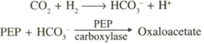

The oxaloacetate then moves into the chloroplast where it is reduced to malate by the enzyme malic acid dehydrogenase which is present inside the chloroplast.

The oxaloacatate is also transaminated into aspartate. The malate diffuses into the cells of bundle sheath through plasmodesmata. (Fig.5.9).The malate is decarboxylated within the cells of the bundle sheath by NADP⁺ dependent malic enzyme to produce CO₂ and pyruvate. While CO₂ is taken up by RuBP to accelerate the calvin cycle the pyruvate diffuses back to the mesophyll cell. The pyruvic acid reacts with ATP and an inorganic phosphate in the presence of an enzyme present in the chloroplast known as pyruvate phosphate dikinase to produce phosphoenolpyruvic acid, AMP and pyrophosphate.
The number of ATP molecules required to synthesis one hexose is, therefore, much more than that of the Calvin cycle. The enzyme pyruvate orthophosphate dikinase brings about the conversation of pyruvic acid into phosphoenol pyruvic acid by breaking up of two energy rich bonds of ATP. The conversion of AMP back into ATP requires expenditure of t wo ATP

molecules. While in Calvin cycle the requirement is 18 ATP in C₄ plants, 12 extra ATP are required because two additional ATP per CO₂ are essential for regenerating ATP from AMP. The reactions of the Hatch-Slack cycle are given in Table 5.
Phosphophenolpyruvate carboxylase, pyruvate phosphate dikinase and the NADP⁺ specific malate dehydrogenase are present in the chloroplasts of the mesophyll cells, whereas RUBP carboxylase NADP specific malic enzyme , and the remaining Calvin cycle enzymes have been found to be present in the chloroplasts of a layer of paranchymatous cells which form a sheath around the vascular bundle. Plasmodesmata have been observed to connect adjacent cells of the bundle sheath and mesophyll layer in maize and sugarcane.

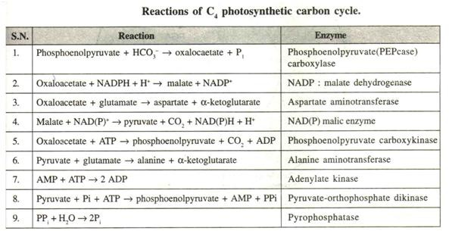
Table: 5

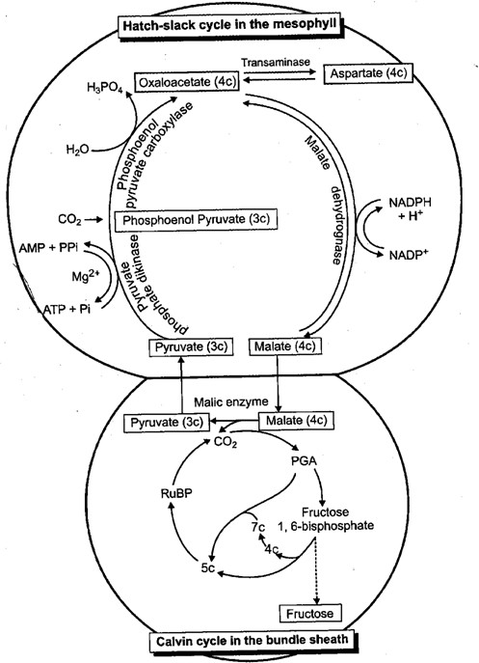
Fig.5.9 Hatch-Slack cycle and Calvin cycle as they occur within the mesophyll and bundle sheath of the C₄ plants

CAM PLANTS

The members of the family Crassulaceae have a special type of metabolism called Crassulacean acid metabolism (CAM) which is also exhibited by member of other families. CAM plant are succulents with thick fleshy leaves, or, when leaves are absent, a swollen photosynthetic stem. CAM plant can synthesize large amounts of malic and isocitric acids at night. Photosynthesis occurs during the day and these acids disappear. The stomata of the leaves remain closed during

the day and open only at night. This is an adaptation to conserve water, since succulents exhibiting CAM are found in dry habitats. During the night Co₂ is taken into the leaves through the open stomata. Because photosynthesis is limited by the storage pool of organic acid and carbohydrate, CAM plants are generally slow growing. (Fig.5.10)
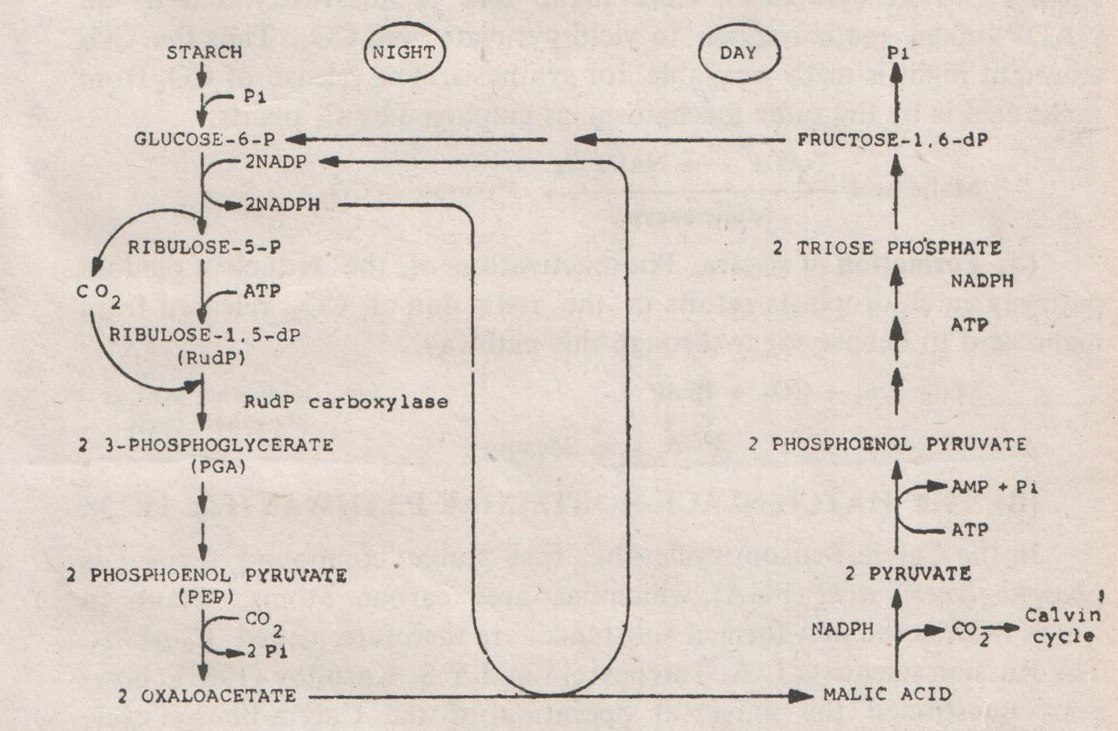
Fig.5.10 Crassulaecean acid metabolism

The CAM mechanism shows various modifications. Well watered Agave americana shows some normal daytime photosynthesis along with some CO₂ fixation at night. In watered Agave deserti, however, dark carboxylation stops and is replaced by normal C₃ daytime photosynthesis.

Reactions of CAM
- Formation of oxaloacetate. The requirements for formation of oxaloacetate are CO₂ and phosphoenol pyruvic acid (PEP). PEP is formed from stored carbohydrate in leaves, particularly starch. In CAM species the stomata remain open at night and CO₂ entering the leaves are fixed by PEP to form oxaloacetate.
CO₂+PEP Oxaloacetate + Pi
- Formation of Malic acid- Oxaloacetate is reduced by malic dehydrogenase to malic acid, which accumulates in the vacuoles of leaf cells. During this step NADPH₂ formed in the pentose phosphate pathway is utilized , and the NADP formed enters the pentose phosphate pathway.

- Release of CO₂ from malic acid. – During the day ATP and NADPH are abundantly available from the photosynthesis reactions. The stomata of the leaves are closed and malate is transported back out of the vacuoles to the cytoplasm. Here malic acid is decarboxylated by an NADP-linked malic enzyme to yield pyruvate and CO₂. Thus the CO₂ stored at night is made available for synthesis. The release of CO₂ from malic acid is by the same mechanism as employed by C₄ plants.
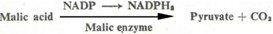

- Formation of sugar – Photoactivation of the reductive pentose pathway in chloroplasts results in the reduction of CO₂ released from malic acid to hexose sugar
through this pathway.

PHOTORESPIRATION

Although C₃ plants respire in the dark, the rate of oxygen utilization increases markedly when the plants are illuminated. Photorespiration is a light driven efflux of CO₂ which proceeds alongside with net CO₂ influx during photosynthesis. Photorespiration may attain 50% of the net rate of photosynthesis. Photorespiration results in CO₂ evolution in light. This has the net effect of decreasing photosynthesis which takes up CO₂ in light. It is therefore a wasteful process which prevents plants from achieving a maximum yield in photosynthesis. In crop species the yield would be greater if photorespiration did not occur. The substrate for photorespiration is glycollate. Breeding of plants with lower photorespiration rates, or inhibiting glycollate synthesis, would be means of increasing crop yields.
Photorespiration is exhibited by crop plants like wheat, rice, other cereals, many legumes and sugar beets, while crops like corn, sorghum and sugarcane do not have photorespiration. (Fig. 5. 11)

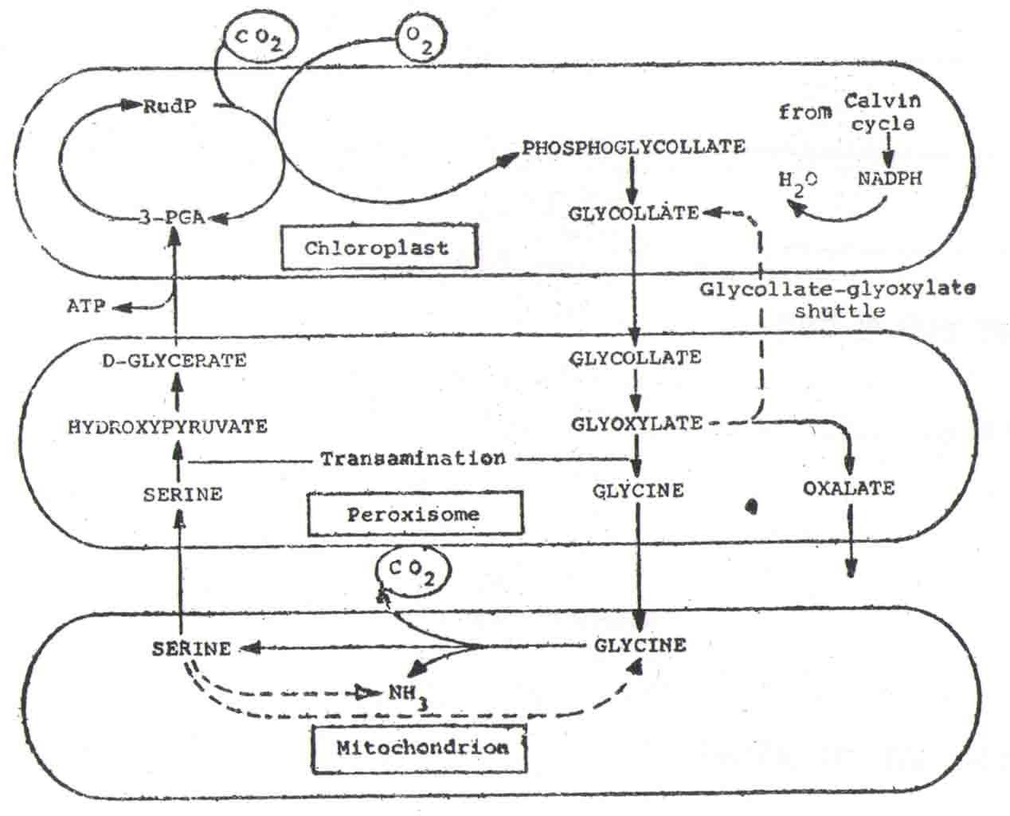

Fig.5.11 Some pathways in glycollate metabolism

The CO₂ compensation point is the CO₂ concentration at a given constant light intensity at which there is a balance between photosynthetic assimilation and respiration. The enzymes of the photo respiratory pathways are present in both C₃ and C₄ plants. The carbondioxide compensation point for common C₃ crop plants is about 40-60 ppm at 25^{O} C, while that for C₄ plants is often less than 10 ppm. The CO₂ generated in C₄ plants during photorespiration is trapped and re-cycled internally by cytoplasmic PEP carboxylase of mesophyll cells. Thus CO₂ efflux is prevented.
Glycollic acid is a 2-carbon compound which is formed in large quantities in the chloroplasts of C₃ plants, from where it moves out into the cytosol.

